Follow the below given instructions to run Hotel Rating Project:-

1. Open and Run “**ServiceRegistry**” project in Eclipse, then goto browser type the following url : [http://localhost:8761/](http://localhost:8761/eureka)
2. It will start **Eureka** Server

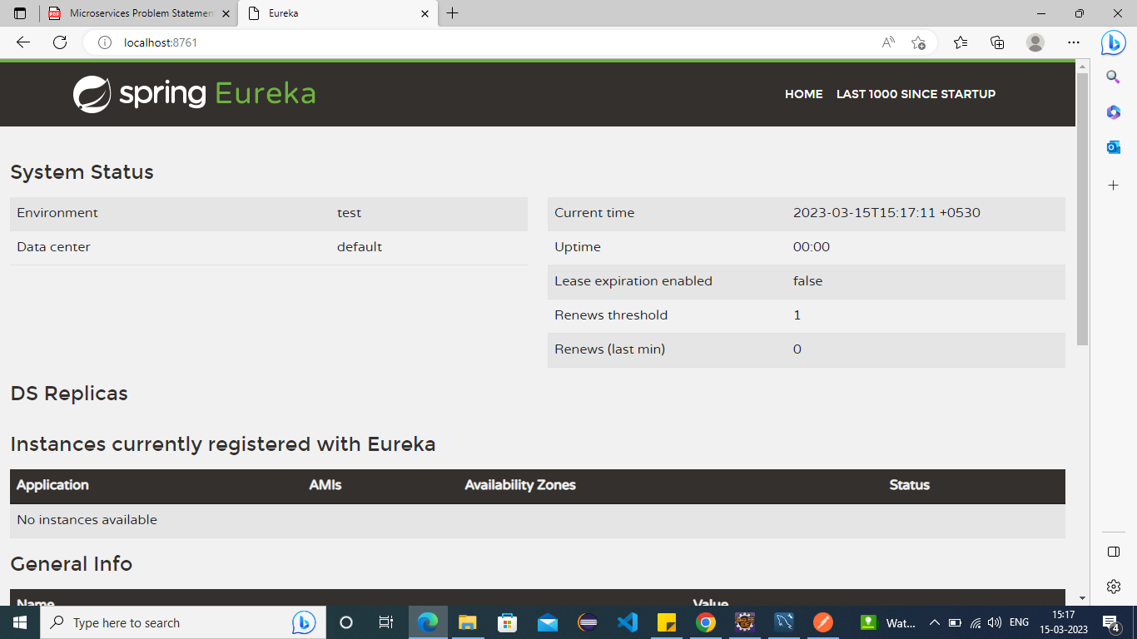

1. Now Open and Run “**HotelService**” App using Eclipse
2. Now Open the “POSTMAN” tool, then use the following “PostMapping” url as follows for new Creating new Hotel Information.

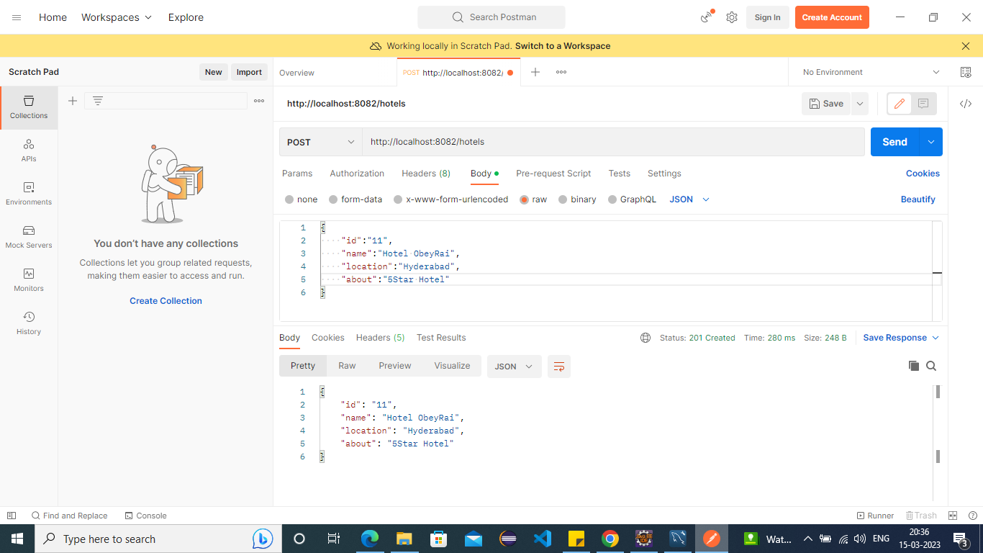

1. To View All Hotels List, “GetMapping” of Following url in POSTMAN Tool

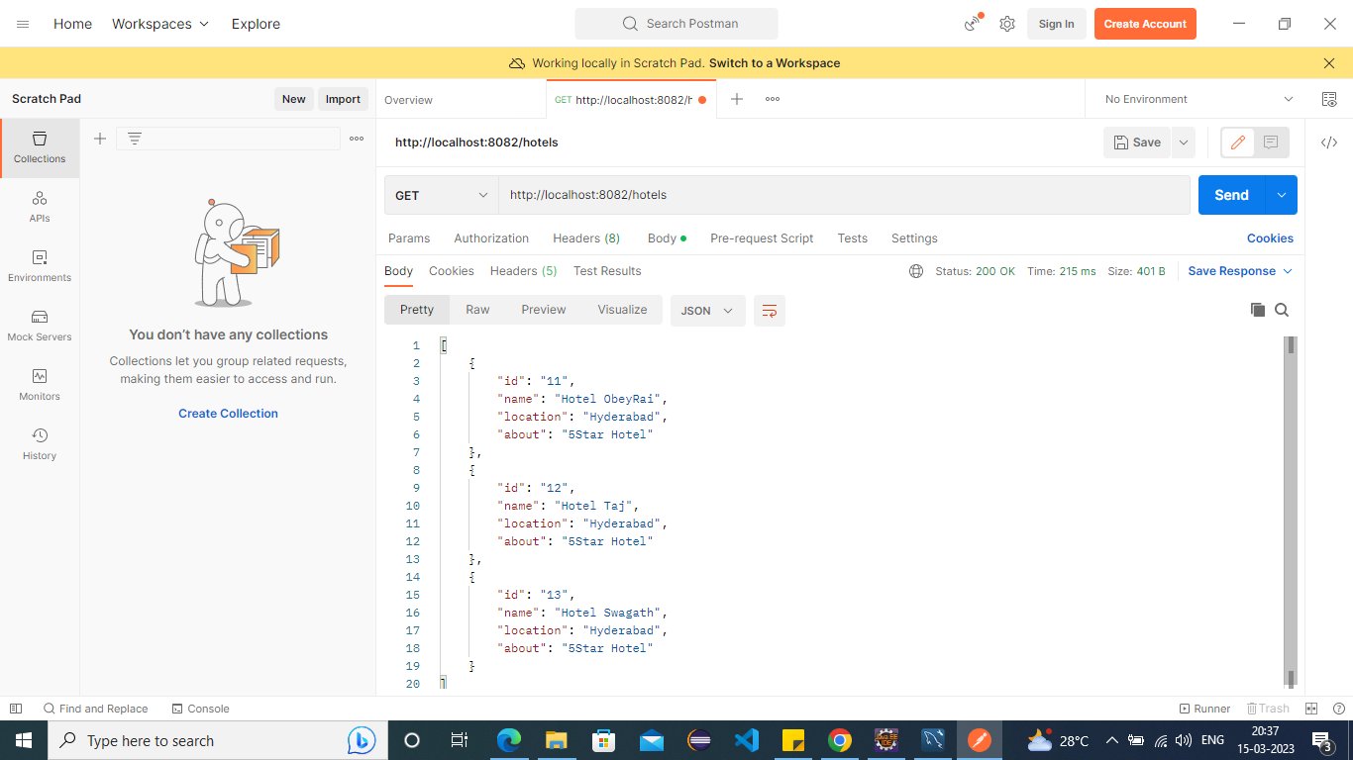

1. To View Specific Hotel Information, “GetMapping” of Following URL in POSTMAN Tool

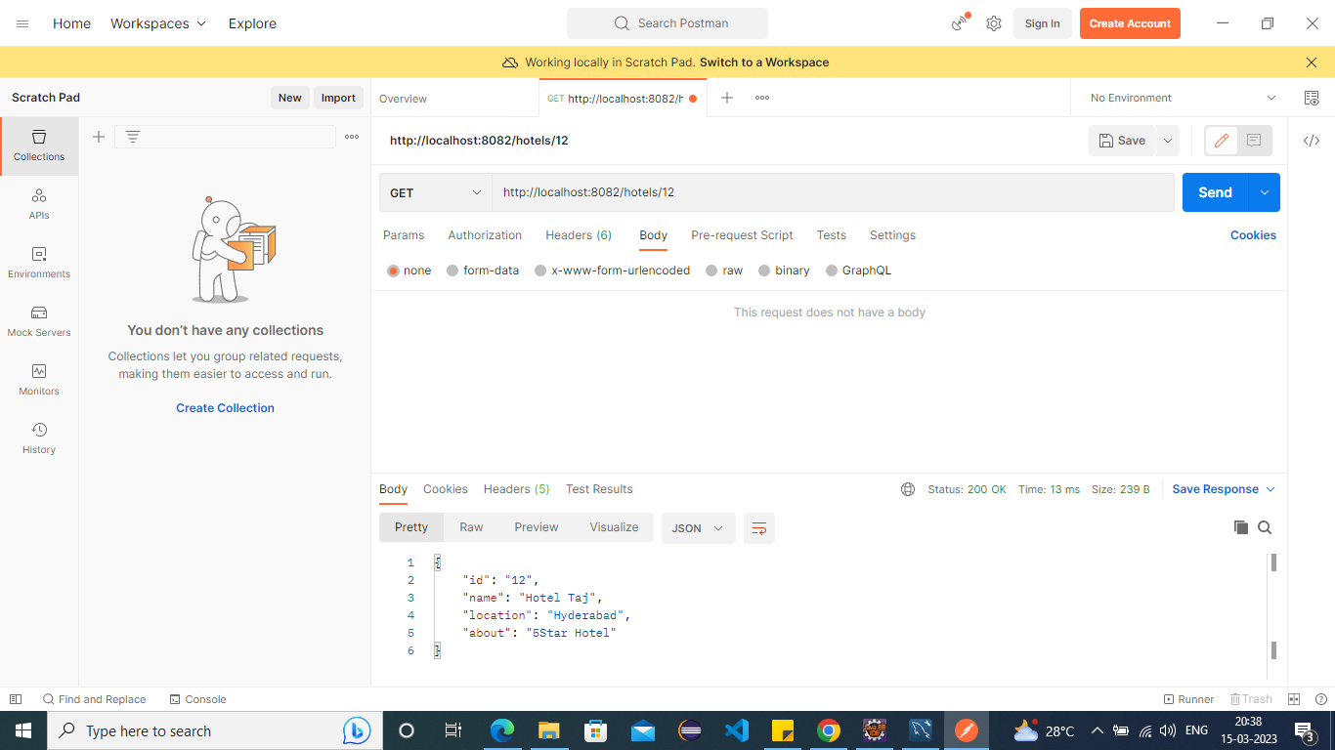

**USER SERVICE**

1. Open and Run “**UserInfoService**” using Eclipse
2. To Create new user, Open “POSTMAN” then use following url of PostMapping

<http://localhost:8083/users>

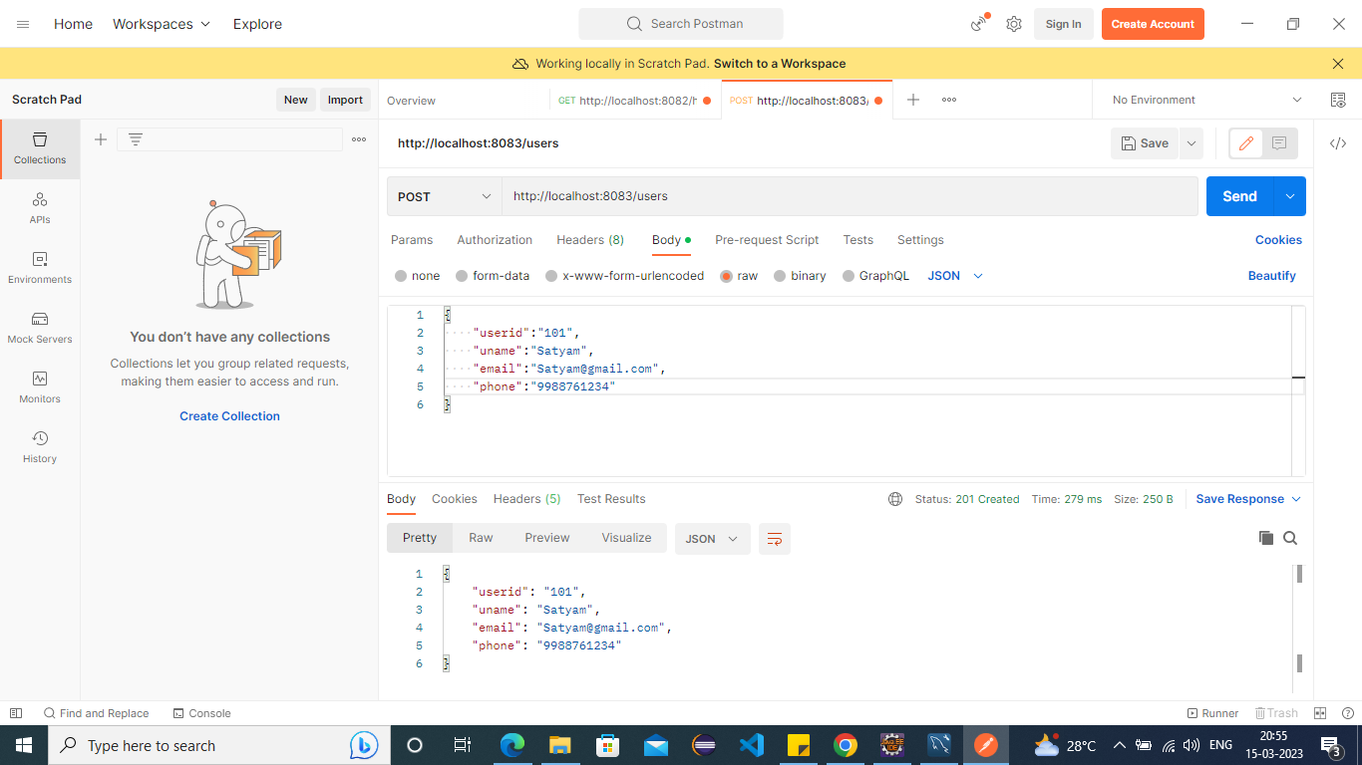

1. To View All Users information, Use following URL in PostMan Tool, GetMapping “<http://localhost:8083/users>”

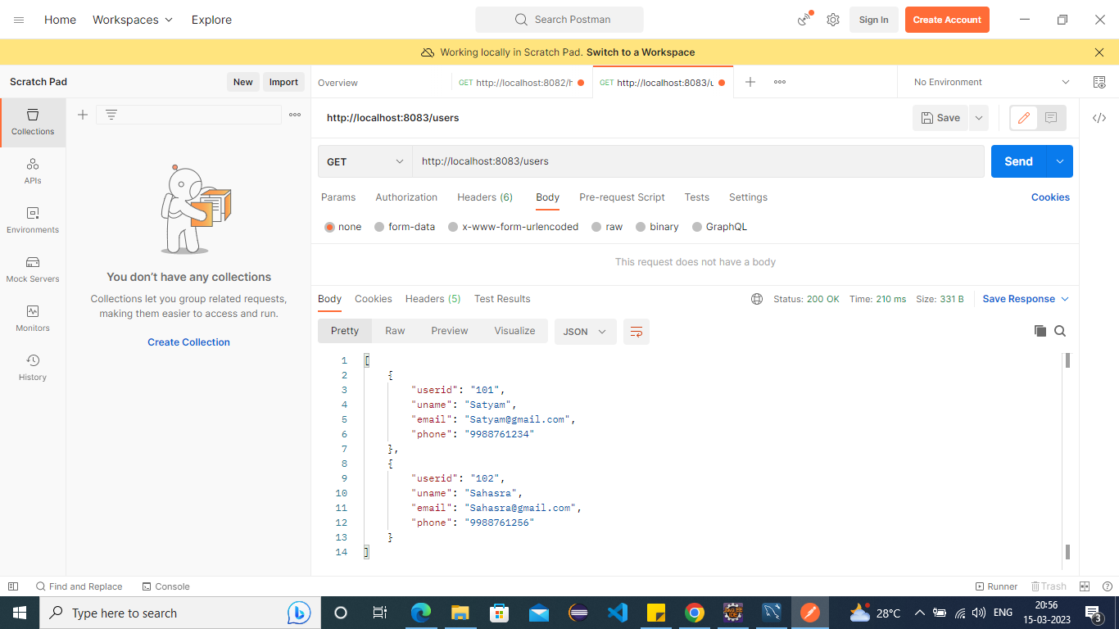

1. To Search Particular UserInfo based UserID :- use the following url in GetMapping in POSTMAN. “http://localhost:8083/users/102”

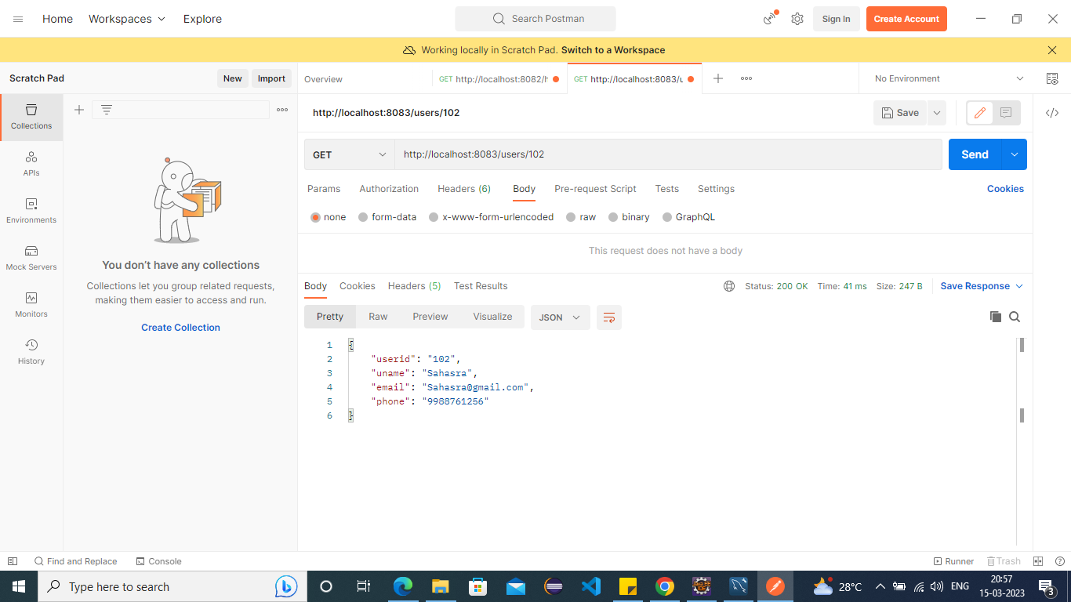

1. To Add Rating for Hotels by users follow below given url: <http://localhost:8083/rating>  
   Use PostMapping

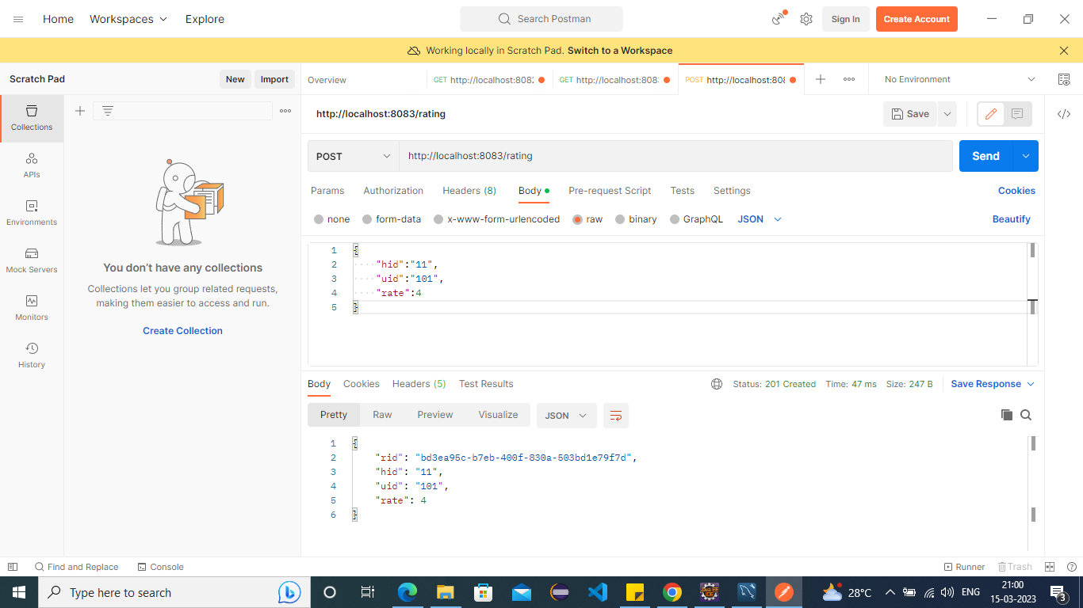

1. To View All Ratings for all hotels GetMapping : http://localhost:8083/rating

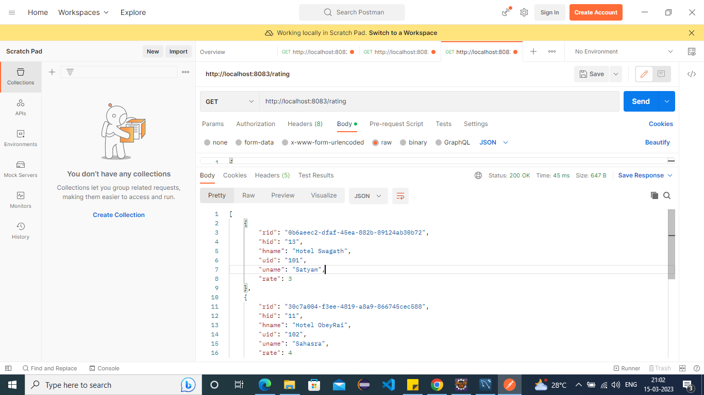

1. To View All Ratings based Hotel ID: GetMapping : http://localhost:8083/rating/13/0/0

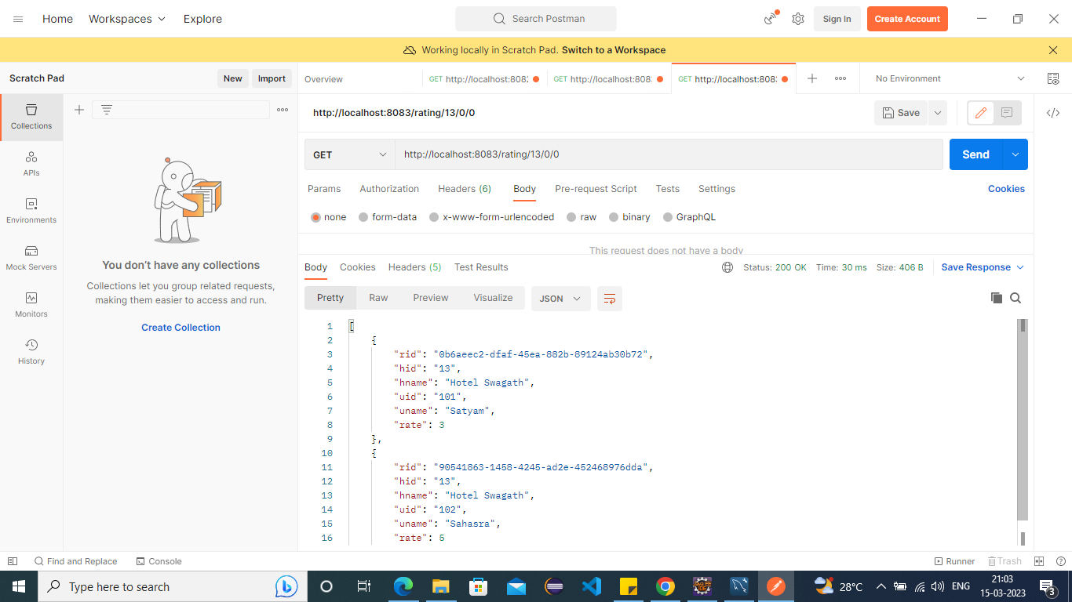

1. To View All Hotels based USer ID: GetMapping : http://localhost:8083/rating/0/102/0

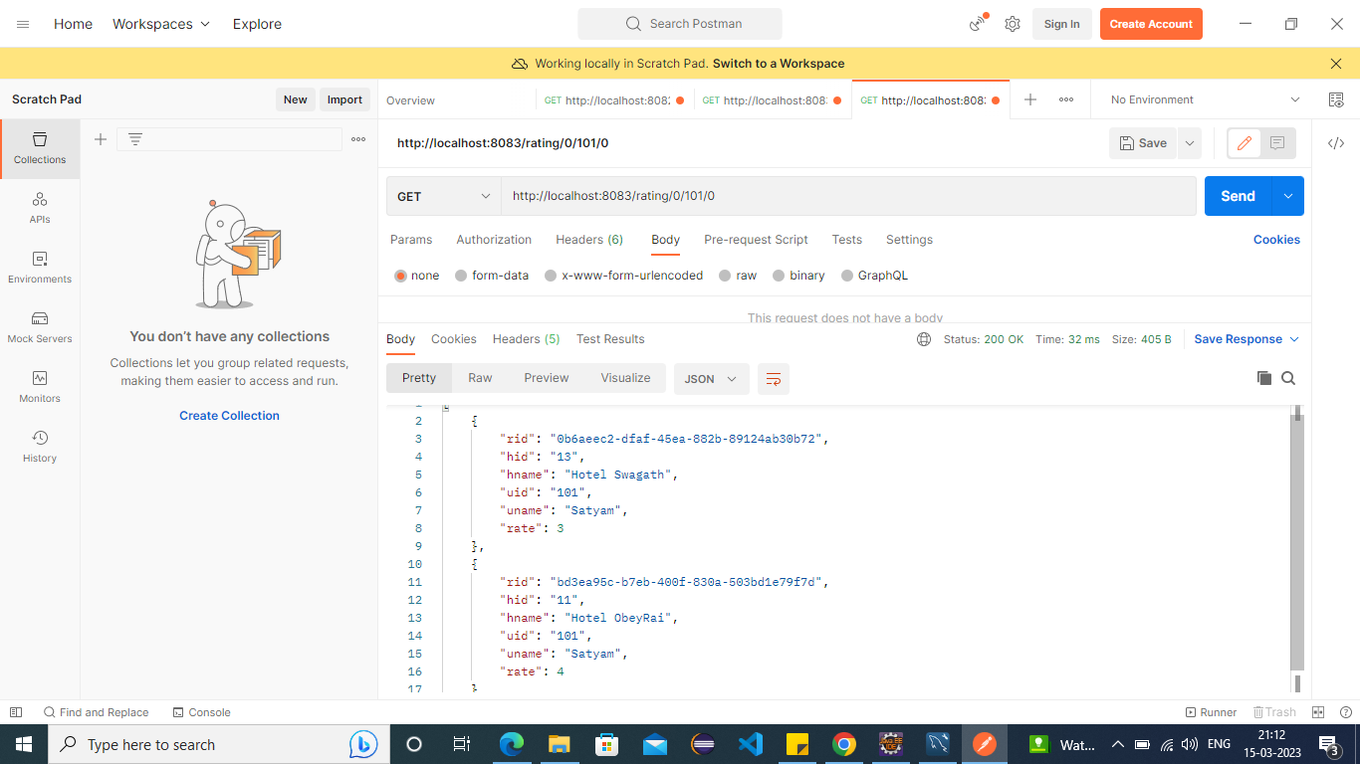

1. To View All Hotels based rating(1-5): GetMapping : http://localhost:8083/rating/0/0/4

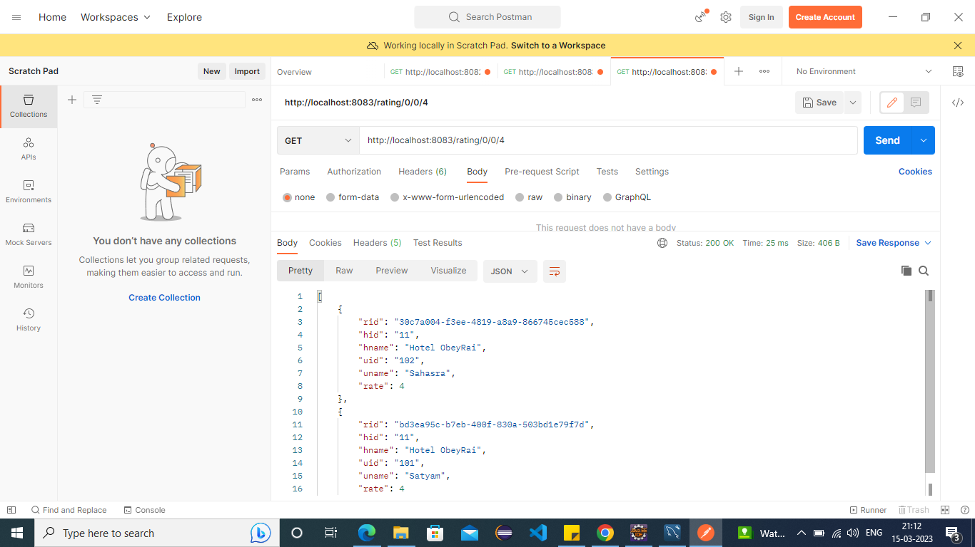

**Database Tables for Sample Data**

1. **Hotels**

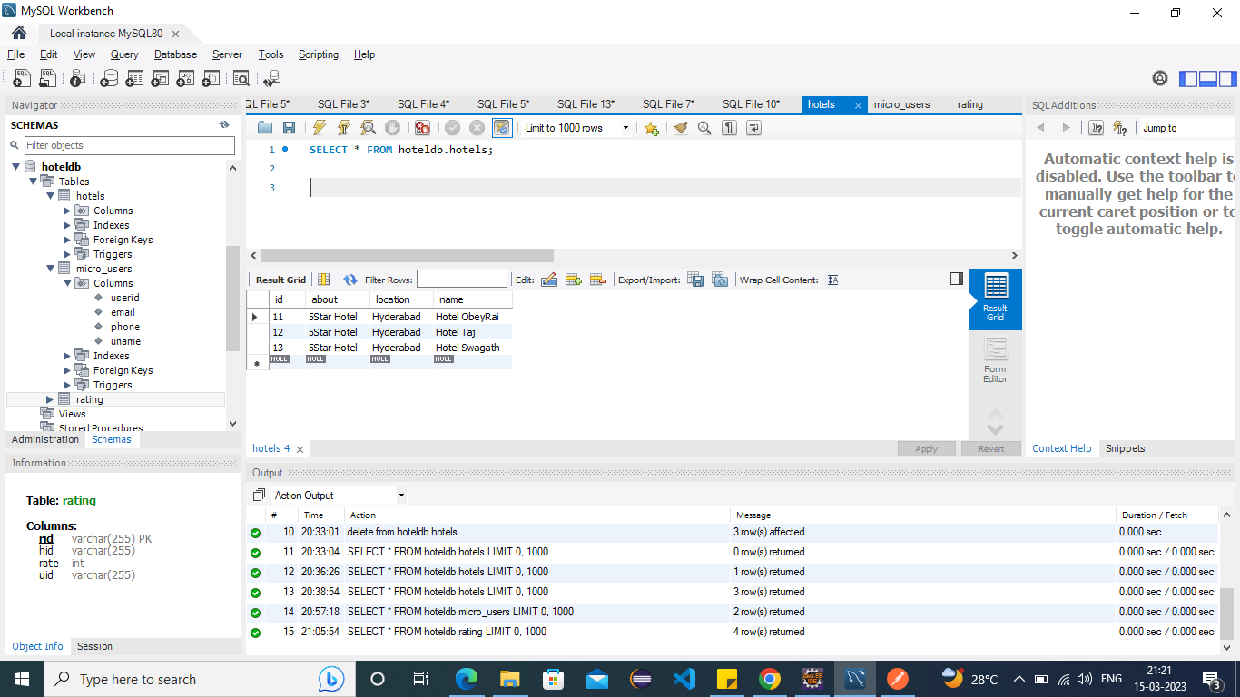

1. **Users**

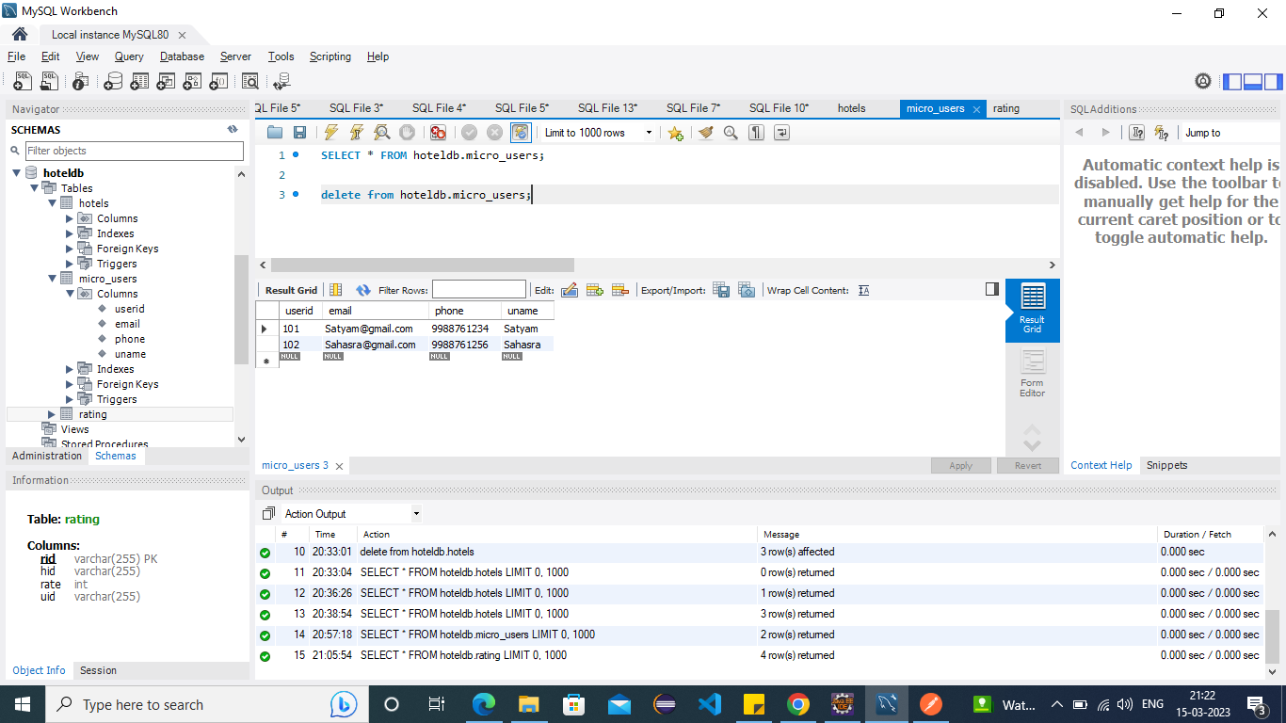

1. **Rating**

